SQL ASSIGNMENT-1

Retrieving Data Using the sql select statement

- Determine the structure of DEPT table and its contents.
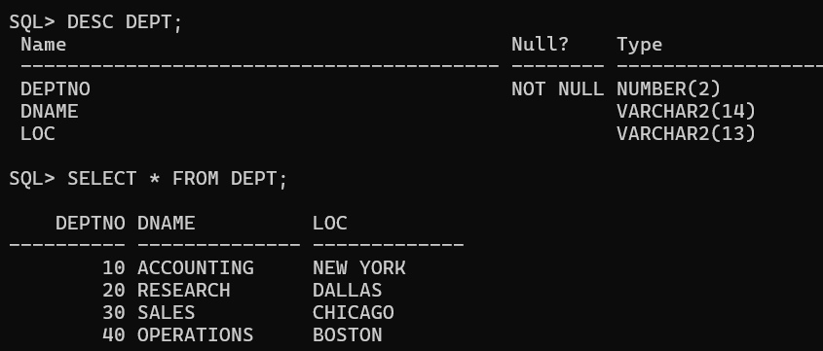

Determine the structure of EMP table and its contents.

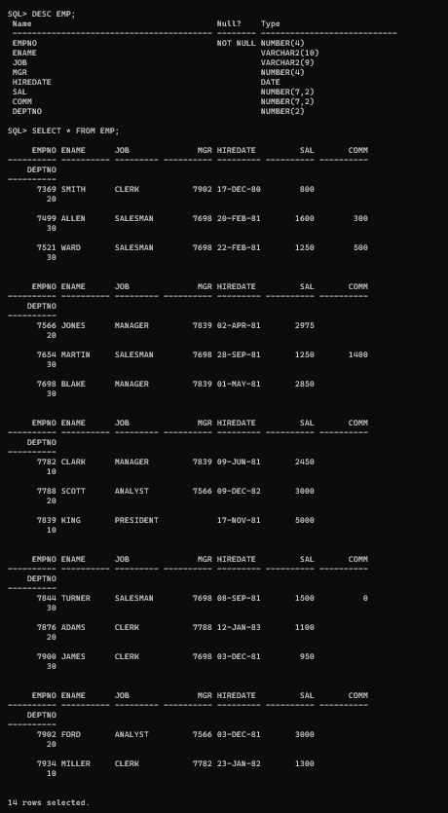

- Display the ENAME and DEPTNO from EMP table whose EMPNO is 7788.
